**What is the Base register and what is the Limit register?**

• Base register: Specifies the smallest legal physical memory address.

• Limit register: Specifies the size of the range.

• A pair of base and limit registers specifies the logical address space.

• The base and limit registers can be loaded only by the operating system.

• Ex: If the base register holds 300040 and the limit register is 120900 then the program can legally access all addresses from 300040 through 420939 (inclusive).

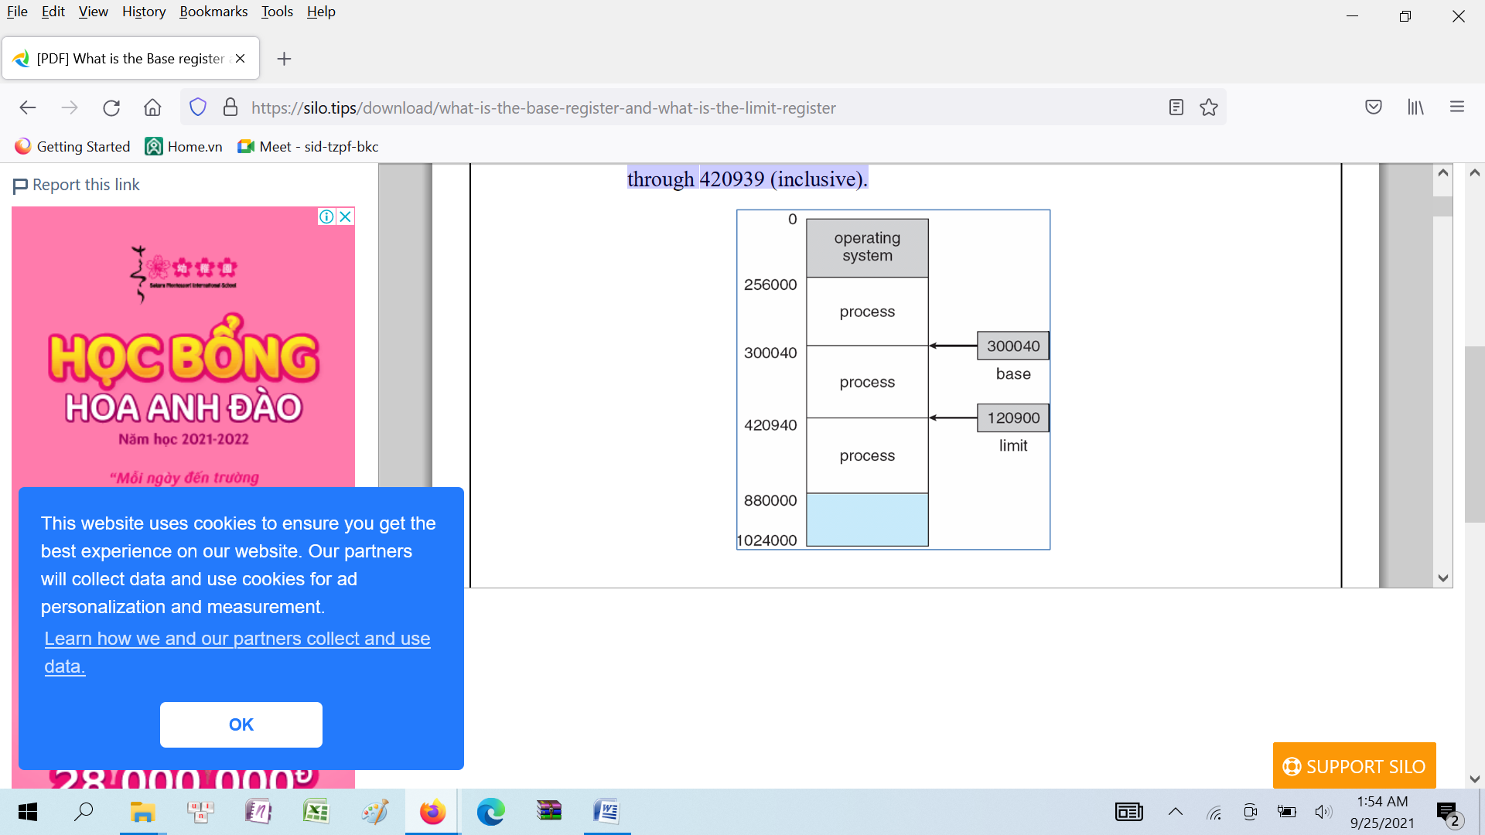

**What are the different stages in which address binding can occur?**

Address binding can occur at three different stages:

• Compile Time: if you know at compile time where the process will reside in memory, then absolute code can be generated.

• Load Time: if it is not know at compile time where the process will reside in memory, then the compiler must generate relocatable code and the final binding is delayed until the load time

.